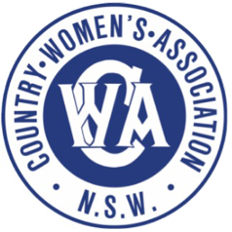International Women’s Day High Tea

Friday 14th March, 2025 2.00 – 4.00 pm

St Matthew’s Anglican Church

The Corso

Manly

Celebrate **International Women's Day**at the 2025 High Tea hosted by Manly Branch of the Country Women's Association of New South Wales. Be delighted with delicious home baked food, community spirit and friendship.

Frances Rush OAM is CEO of the Asylum Seekers Centre will be our guest speaker. She has more than 40 years’ experience as a social worker in both the government and community sectors, as well as a wealth of experience in advocacy and policy development.  Prior to her role as the ASC’s CEO, Frances held senior executive roles with the NSW Department of Justice in Guardianship and worked with the Royal Commission into Institutional Responses into Child Sexual Abuse.

Funds raised are used to support women and families throughout NSW.

The High Tea is at St Matthew's Church, 1 Darley Road, Manly at 2pm on Friday 14th March, 2025.

Tickets available on Humanitix – scan the QR to buy online

